*Updated 17.5.2019*

# LUT VDI - Software and Virtual Desktop Portal

From the portal you can access and use LUT programs remotely for example from home using your private computer or access the same programs from LUT library or classroom computer. Some programs can be run straight from the portal, but due to technical reasons or licensing limitations, some programs are installed into virtualized Windows desktops, where you need to log in before accessing the programs inside the desktop.

***There are two ways how to run software and desktops from the portal: Using VMware Horizon Client or run them inside a web browser.*** Running programs or desktops using a wwwbrowser has limitations. You are not able to use local printer and you have no access to local disk drives. In addition, text copy-paste is also not straightforward.

Be aware that there are limited number of desktops available and some programs might have limited number of licenses. Due to these limitations there might come situations, where desktops or programs are not available. Some programs might also be available only on campus area due to licensing restrictions. You can access them by using for example classroom or library computers or by using Eduroam wireless network with your own computer.

***Log off from desktop or close the program after you are finished using it****.* System will also perform an automatic log off after some period of time, but by logging off you ensure that you will instantly free the used licenses for next user.

***Using VMware Horizon Client is a recommended way to open portal resources instead of a browser****.* When you use VMware Horizon Client you can use a local printer and have access to local computer disk drives and USB flash drives. Client can be downloaded and installed for different operating systems and mobile devices from link below:

[**https://www.vmware.com/go/viewclients**](https://www.vmware.com/go/viewclients)

Your computer might restart automatically after the installation, so make sure your documents which you are working with are saved.

VMware Horizon Client is installed on classroom computers. For staff computers it can be installed from Software Center.

**1) Install VMware Horizon Client from Software Center for LUT staff computers or from** [**https://www.vmware.com/go/viewclients**](https://www.vmware.com/go/viewclients) **for private computers or mobile devices**

## 2) Opening portal resources with VMware Horizon Client

Start the client and double click “Add Server”.

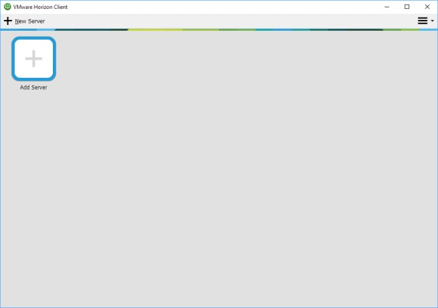

Type “view.lut.fi” as connection server name and click “Connect”. Connection server will be stored into VMware Horizon Client for later use.

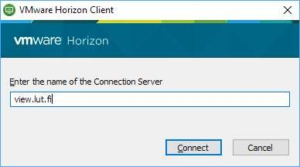

After entering the name of the Connection Server and clicking “Connect” opens a Login-window where you have to type your username and password. You can also use your e-mail address as user name.

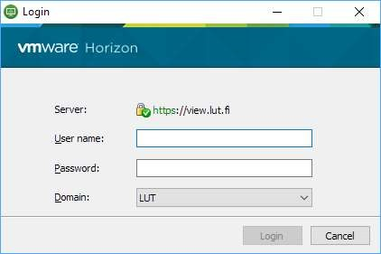

After logon, all available programs and desktops are shown in VMware Horizon Client and can be started by double clicking.

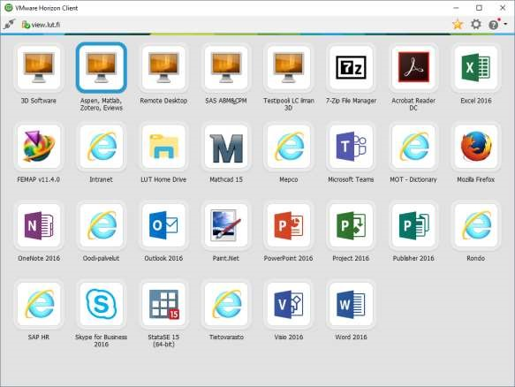

When Horizon Client is opened next time, the client remembers the server:

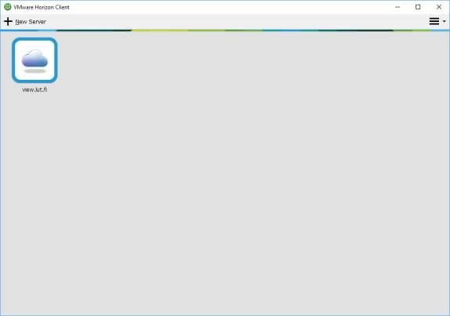

You can select “Autoconnect to this Server” by right clicking the server.

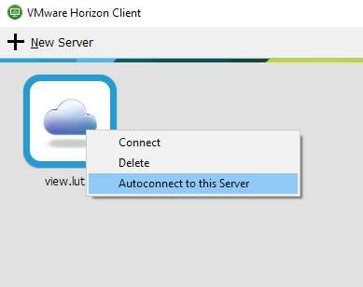

## 3) Using a web browser

*If you are in LUT network such as in computer classrooms*

* Navigate to address [https://vim.lut.fi](https://vim.lut.fi/) and you should be automatically signed in to the portal without entering your username or password

*If you are outside of LUT network, for example at home or using LUT Eduroam*

* Navigate to address [https://vim.lut.fi](https://vim.lut.fi/)

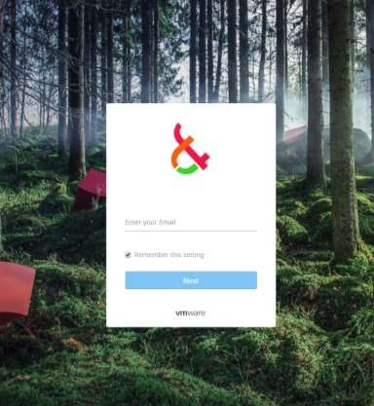

* Enter your email address (firstname.lastname@lut.fi) and click next to enter your password. You will be redirected to portal.

You can deselect the “Remember this setting” if you want. Option does not store your password, only your email address.

After logon, all available software and desktops hosting other programs are shown in Workspace ONE portal.

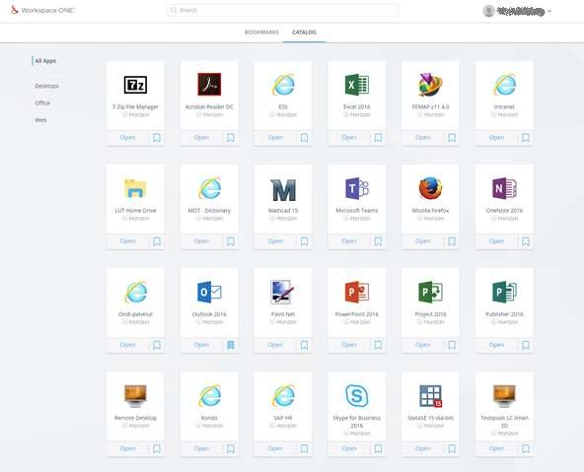

Favorite programs and desktops can be bookmarked by clicking the “ribbon” icon. By doing that they will be linked to “Bookmarks” tab.

You can also click the desktop icon to show what programs are installed on desktops.

When you are using www-portal, you can choose how to open programs or desktops. If you do not have VMware Horizon Client installed, program or desktop should open into a new browser tab.

You can select how to open programs or desktops by clicking your name on upper right corner, selecting “Settings” and then “Preferences”.

***As already mentioned, using VMware Horizon Client is a recommended way to open portal resources instead of a browser****.*

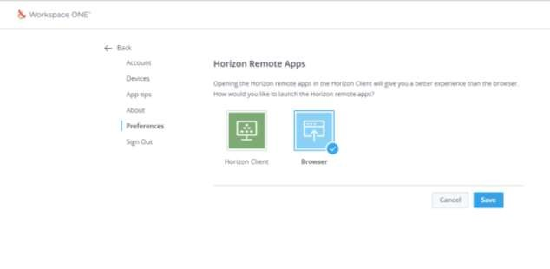

## Additional info

### 1) Connecting and using USB devices in VMware Horizon Client

If you need to use for example a local USB printer or a flash memory with a virtual machine or a program, follow the guidance below. ***Please note that the USB device is not available on the host computer when it’s used with VMware Horizon Client.***

Go to settings by pressing  button in upper right corner of VMware Horizon Client and choose “USB Devices” tab.

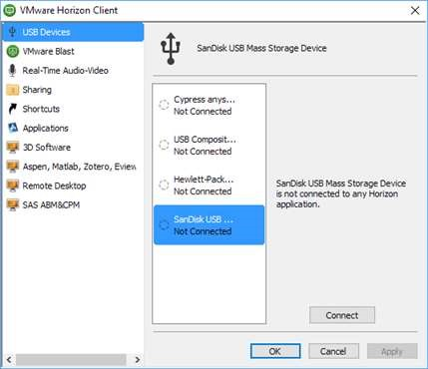

Choose the USB device and pick in which desktop or program you want to use the USB device and click “Connect”. You can connect multiple USB devices if needed.

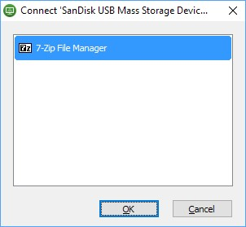

Connecting a flash drive for a first time a popup might appear. Click “Allow”.

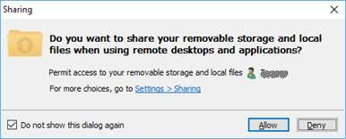

After use you can disconnect the USB device by clicking “Disconnect” button.

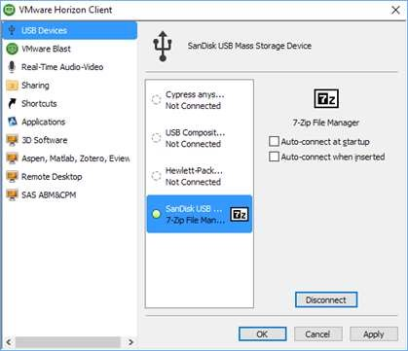

### 2) Share a folder from local computer to a program or a virtual desktop

You can access host computer folders from “Sharing” tab. Shared folders will be mounted as network drives. Click “Add”-button and choose a folder or folder that you want to share with a program or a desktop.

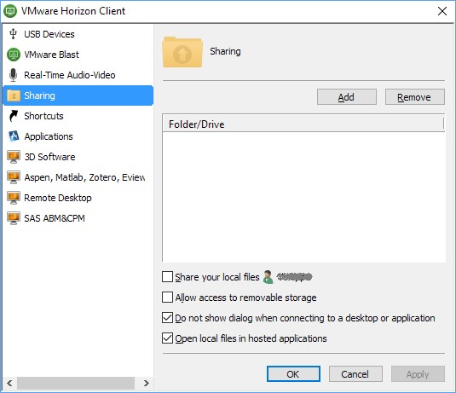

Example: Shared c:\temp –folder is automatically mounted as Y: drive.

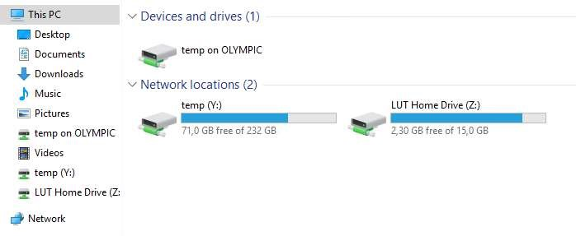

### 3) Changing display settings on desktops

As a default, all desktops will utilize all monitors. You can select for example a “floating window” mode by choosing “Window – Large” or “Window – Small”. The selection will be remembered for later use.

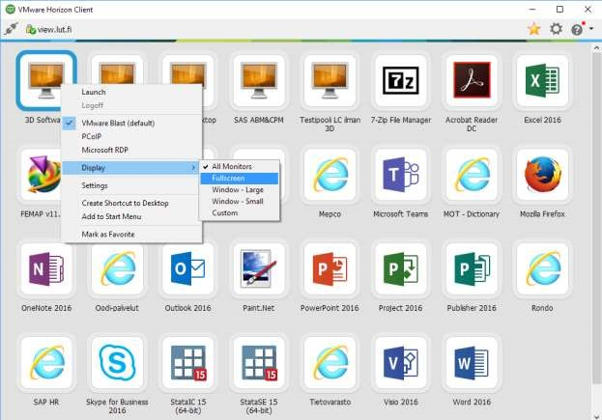

You can resize windowed desktops or programs by dragging from a corner of a window.

***On a launched desktop, sharing, USB and other settings can also be accessed from a VMware Horizon Client desktop window.***

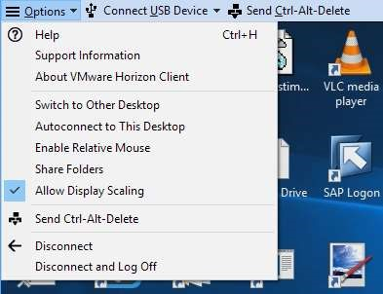

***VMware Horizon Client documentation for different operating systems:***

<https://docs.vmware.com/en/VMware-Horizon-Client-for-Windows/index.html>

<https://docs.vmware.com/en/VMware-Horizon-Client-for-Mac/index.html>

<https://docs.vmware.com/en/VMware-Horizon-Client-for-Linux/index.html>

<https://docs.vmware.com/en/VMware-Horizon-Client-for-iOS/index.html>

<https://docs.vmware.com/en/VMware-Horizon-Client-for-Android/index.html>